H.T No
Regulations:
A15

Sreenidhi Institute of Science and Technology
(An Autonomous Institution)
Code No: 5AC07 Date: 21-Jan-2023 (FN)

B.Tech IV-Year I- Semester External Examination, January-2023 (Supplementary)
CONTROL SYSTEMS (ECE)

Time: 3 Hours Max.Marks:75 Note: a) No additional answer sheets will be provided.
b) All sub-parts of a question must be answered at one place only, otherwise it will not be valued.
c) Missing data can be assumed suitably.

Bloom's Cognitive Levels of Learning (BCLL)
Remember | L1 | Apply | L3 | Evaluate | L5
Understand | L2 | Analyze | L4 | Create | L6

Part - A Max.Marks:25

Answer all QUESTIONS.
 |  | BCLL | CO(s) | Marks
1 | Illustrate the working principle of synchro transmitter. | L2 | CO1 | [2M]
2 | What are standard test signals? Why they called “standard”? | L1 | CO2 | [2M]
3 | For a system with characteristic equation, , examine stability. | L4 | CO3 | [2M]
4 | What is frequency response? What are advantages of frequency response analysis? | L2 | CO4 | [2M]
5 | Describe the necessity of lead-lag compensator. | L4 | CO5 | [2M]
6 | Discuss about the properties of state transition matrix. | L2 | CO6 | [3M]
7 | What are the advantages of closed loop control systems over open loop control systems. | L2 | CO1 | [3M]
8 | In Routh array what conclusion you can make when there is a row of all zeros? | L3 | CO3 | [3M]
9 | How the modal matrix can be determined? | L4 | CO6 | [3M]
10 | What is the relation between stability and coefficient of characteristic polynomial? | L2 | CO3 | [3M]

Part – B Max.Marks:50
ANSWER ANY FIVE QUESTIONS. EACH QUESTION CARRIES 10 MARKS.

 |  |  | BCLL | CO(s) | Marks
11. | a) | Why negative feedback is preferred in a closed loop system, and also explain effect of feedback on control systems on stability and sensitivity. | L2 | CO1 | [5M]
 | b) | Write the differential equations governing the mechanical system shown below.  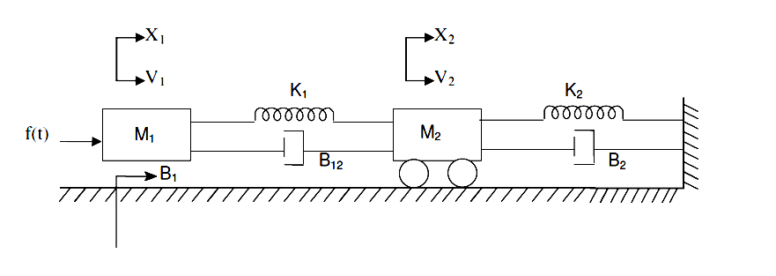 | L4 | CO1 | [5M]
12. | a) | Define the following time domain specifications: (i) Rise time (ii) Delay time (iii) Peak time (iv) peak overshoot (v) Settling time. | L1 | CO2 | [5M]
 | b) | The open loop transfer function of a unity feedback system is 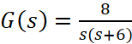 determine the nature of response of the closed loop system for a unit step input. | L3 | CO2 | [5M]
13. | a) | Discuss the effects of addition of pole and zero in  transfer function. | L5 | CO3 | [5M]
 | b) | Sketch the root locus plot for the system when open loop transfer function is given by 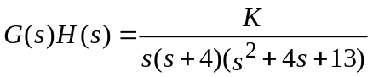 | L3 | CO3 | [5M]
14. | a) | Derive an expression for Resonat peak (Mr) of the second order system. | L3 | CO4 | [5M]
 | b) | Sketch the Bode plot for the given transfer function and obtain gain margin & Phase Margin  G(s) = 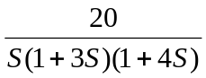 | L4 | CO4 | [5M]
15. | a) | a) State and explain Nyquist stability criteria. | L2 | CO5 | [5M]
 | b) | b) Sketch the Nyquist plot for the open loop transfer function given bellow. Comment on stability.  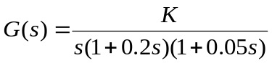 | L3 | CO5 | [5M]
16. | a) | Compute the solution of the matrix of the non  homogeneous state equation  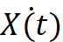= AX(t)+BU(t) ; X(0) = X0 | L5 | CO6 | [5M]
 | b) | Construct the signal flow graph and state model for a system whose transfer function is 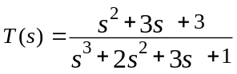 | L4 | CO6 | [5M]
17. | a) | Find the transfer function C/R using block diagram reduction method.  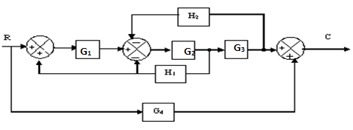 | L5 | CO1 | [4M]
 | b) | A system has the transfer function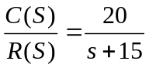. Determine its step and impulse responses with zero initial conditions. | L3 | CO2 | [3M]
 | c) | Construct Routh array, determine stability and find the location of roots for the systems represented by the following characteristic equation.  S⁴+8s³+18s²+16s+5=0 | L2 | CO3 | [3M]
18. | a) | The open loop transfer function of a unity feedback system is given by  G(s) = 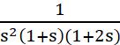. Sketch the polar plot and determine the gain margin and phase margin. | L2 | CO4 | [4M]
 | b) | List the differences between Lag compensator and Lead compensator. | L2 | CO5 | [3M]
 | c) | Given the system 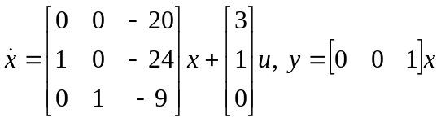 find out its characteristic equation. | L5 | CO6 | [3M]

-- 00 -- 00 –

